**DSP**

**Matlab Project**

|  |  |
| --- | --- |
| **NAME** | **ID** |
| **Abdullah Fathy Mohammed El-Zohiery** | **18011024** |
| **Abdullah Mohammed Farag Soliman** | **18011032** |
| **Adel Mohammed Mahmoud Hashem** | **18010880** |
| **Mostafa Ahmed Abdelsalam El-Hosary** | **18011775** |
| **Mahmoud Ahmed Abdelsalam Mohamed** | **18011654** |

**Input photo** “photo to be processed”

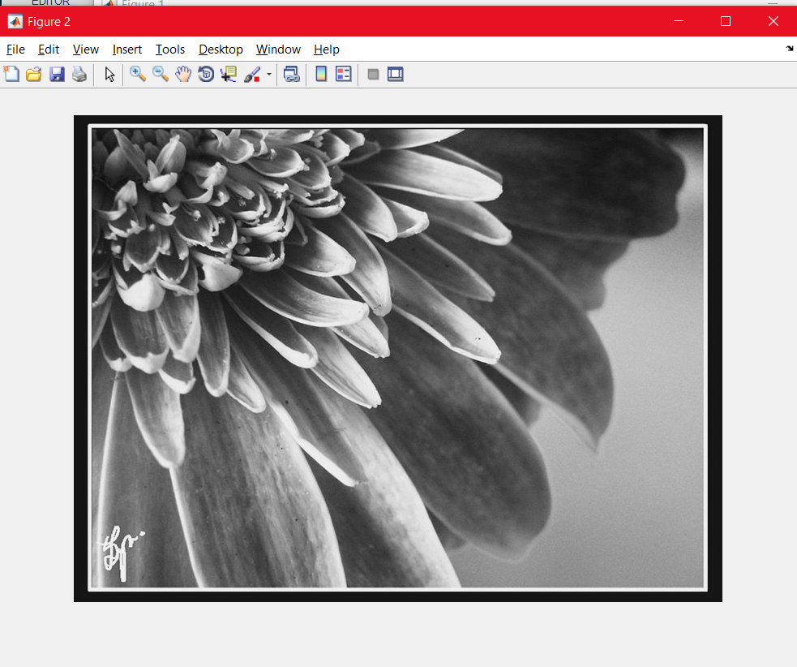

**Operation** step by step

**I**) **script to compute** **C**N “for N= 8”

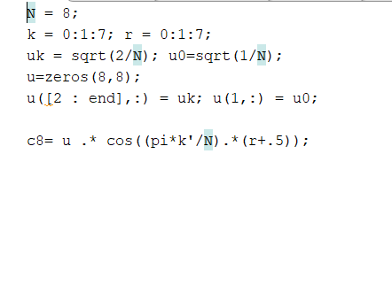

**II) Divide function**

“to split the image matrix into small blocks of size 8x8”

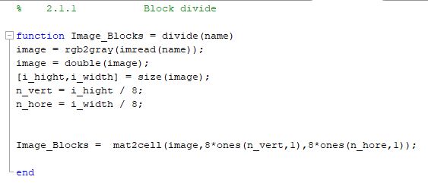

**III)Quantization function**

“produce the quantized block split image.”

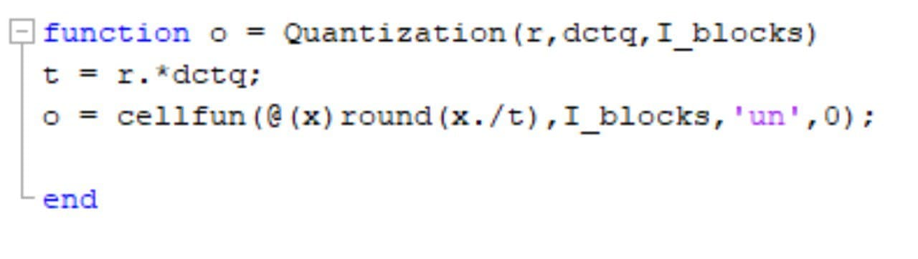

**IV)Rescaling function**

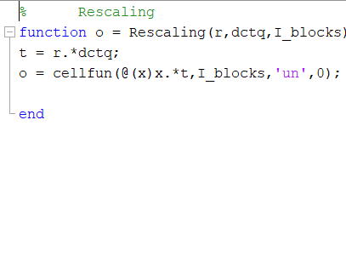

**V)The inverse block DCT** using the routine ”blockDCT”

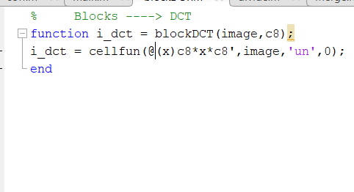

**VI)Merge function**

“merge the reconstructed split image into a conventional image”

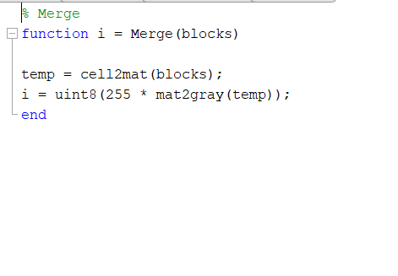

**VII) The Main Function**

“The Implementation ”

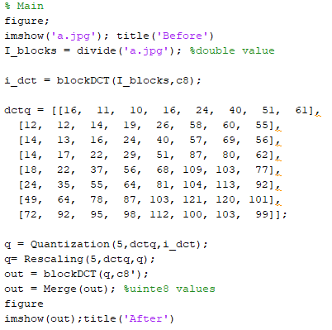

**Output photo**

**When r = 0.5**

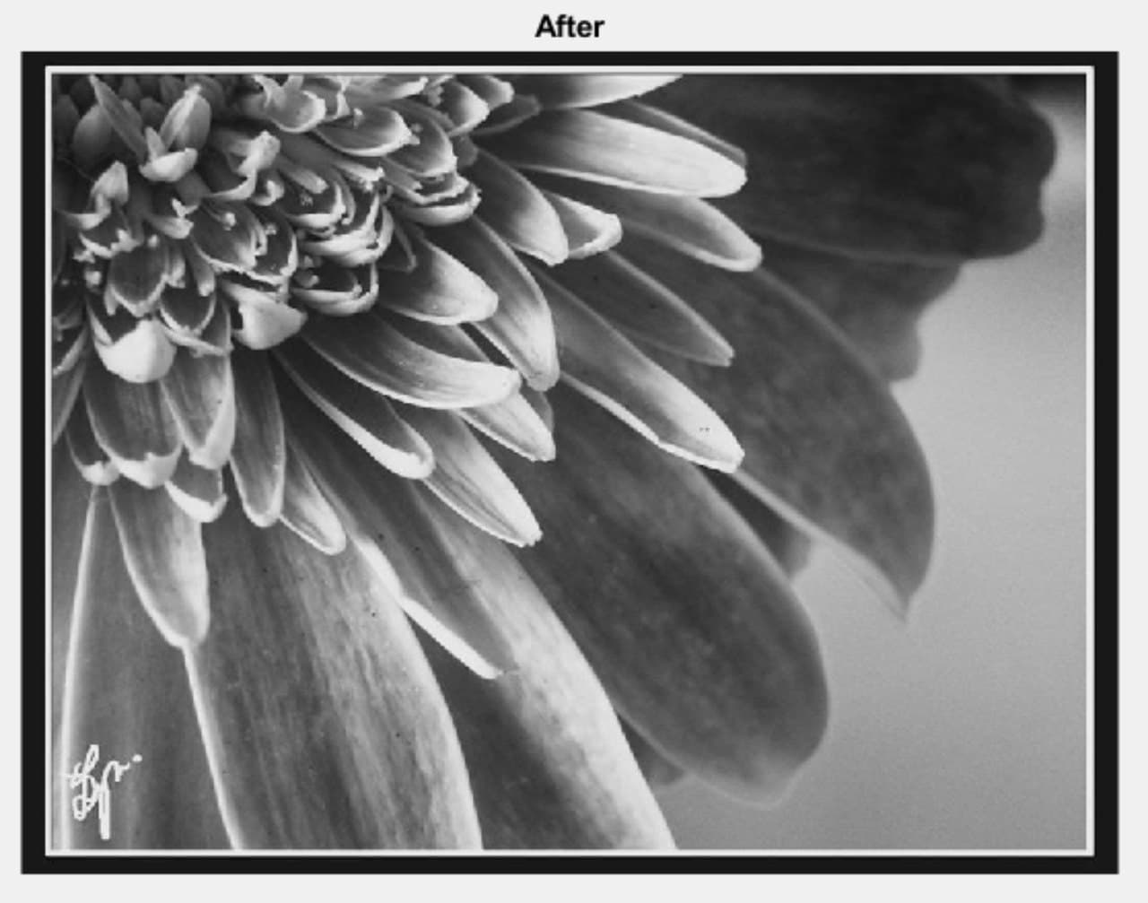

**When r=1**

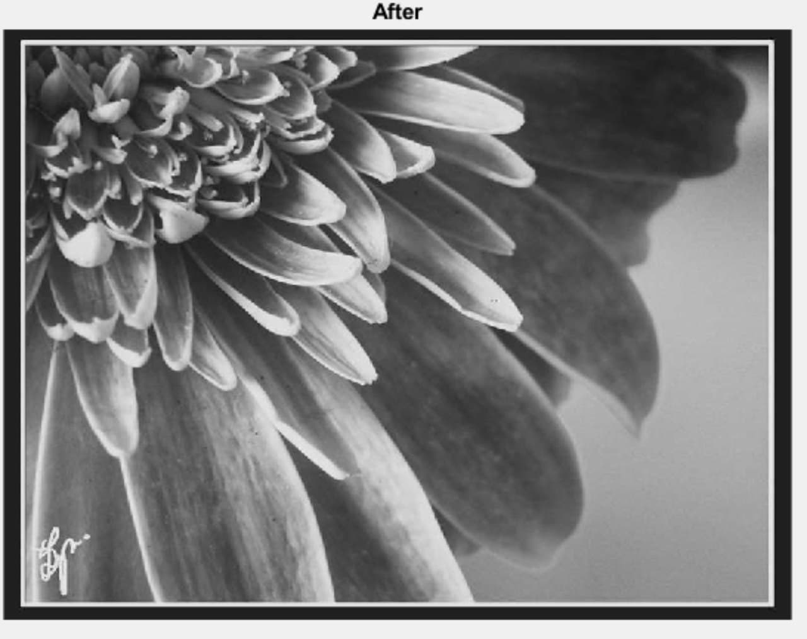

**When r=10**  
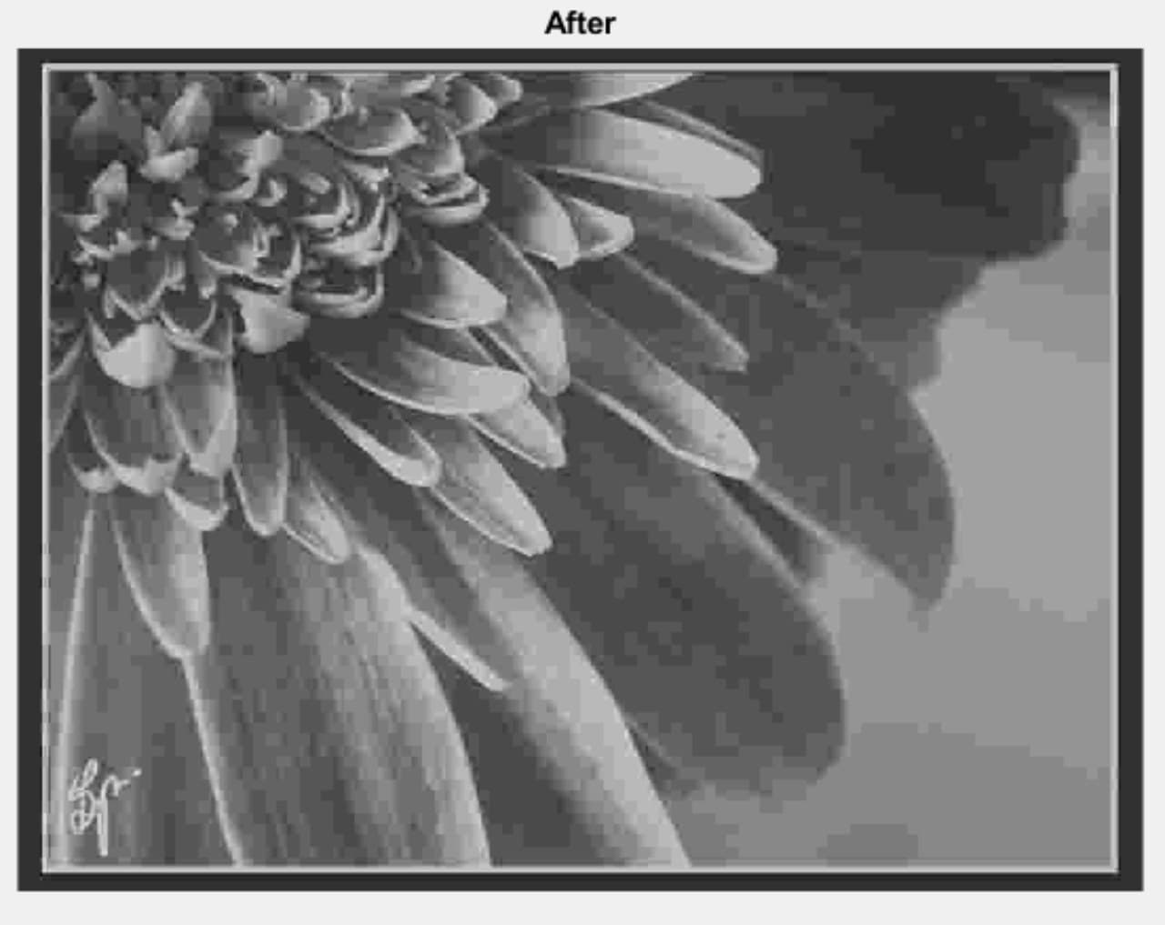

**When r =5**  
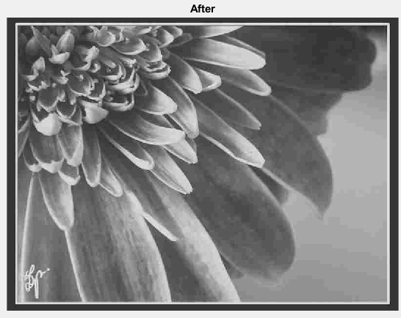

**When r =7**  
